Lab 2 Screenshots

1. a) Create a database by name HealthStore

c)

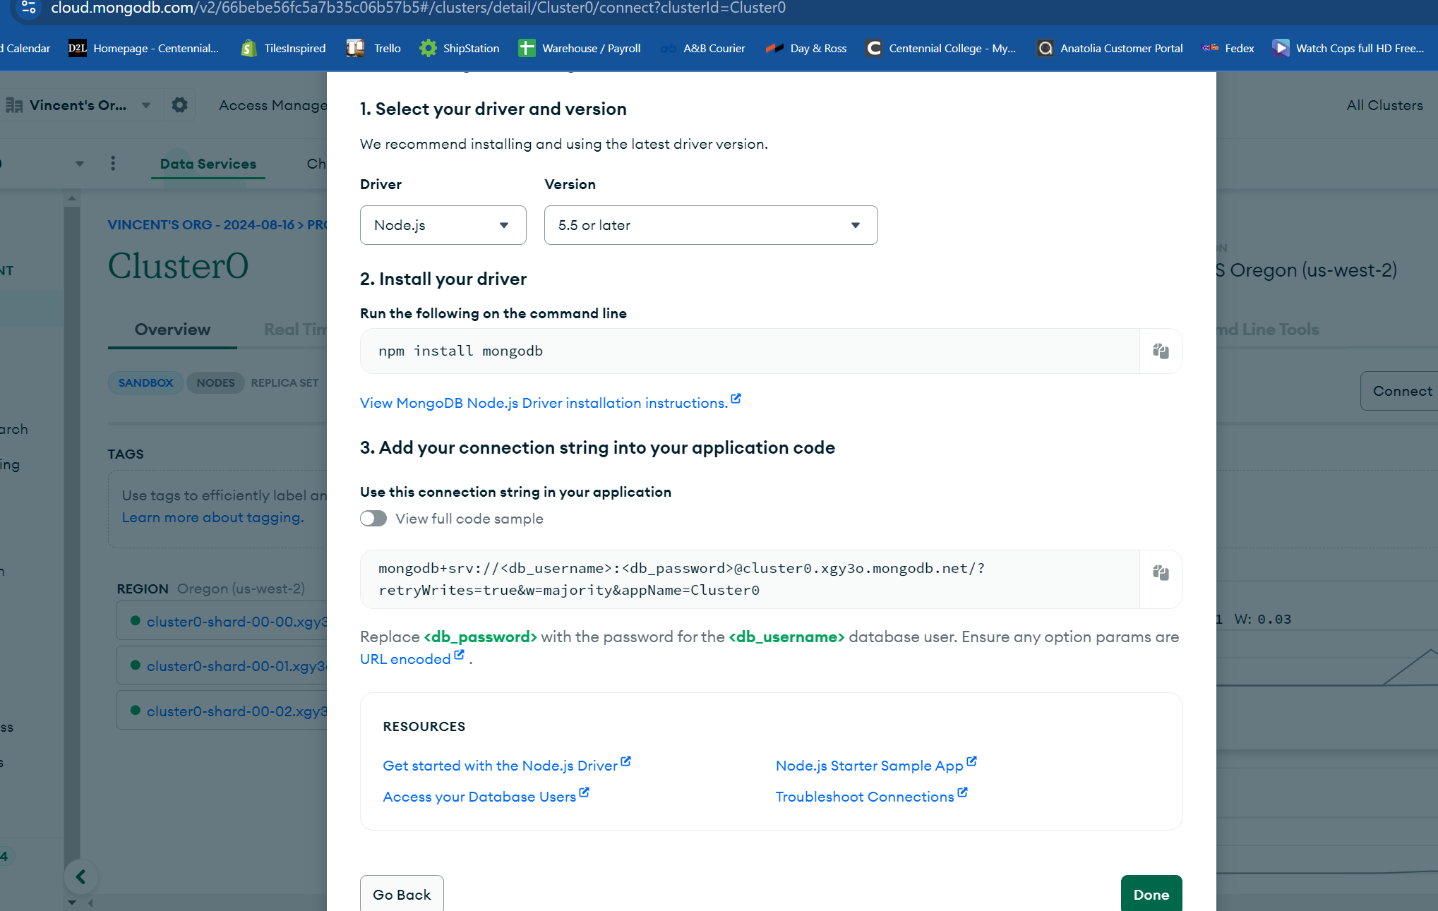

2.

3.

Create supplement

Get all supplements

Get supplement by ID

Delete supplement by id

Delete all supplements

